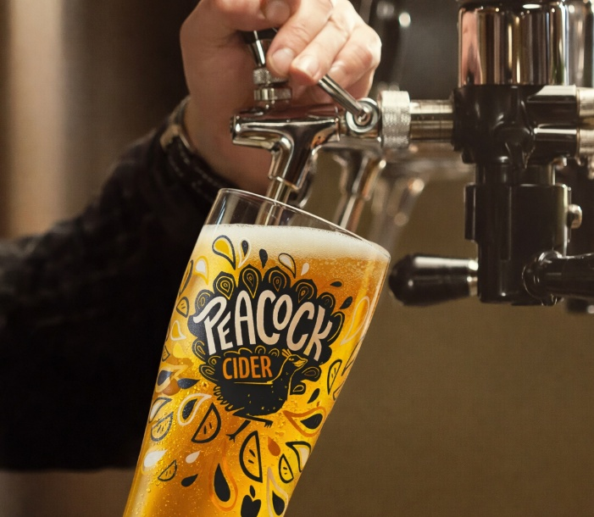
Peacock Cider Launches In Draught Format
Peacock Cider is introducing a draught format, bringing the UK’s only cider developed specifically to complement Asian cuisine to the bar tap for the first time.
Available from late March, Peacock will be rolled out in 30L kegs in two flavours, Crisp Apple and the acclaimed Mango & Lime. Mango & Lime has won multiple awards over the years, including Silver at the World Cider Awards 2025, reinforcing its credentials as a standout flavour within the category. The launch strengthens Peacock’s foothold in Asian dining and in wet-led Asian venues such as desi pubs.
Demand for Asian cuisine in the UK remains strong. According to a recent YouGov survey, 45% of Britons had eaten Chinese food, and four in ten had eaten Indian food in a restaurant, takeaway or delivery setting within the past three months, underlining the scale and frequency of these dining occasions. (Source: https://yougov.com/en-gb/articles/52011-whos-eating-what-the-demographic-divide-behind-britains-favourite-cuisines)
Peacock was crafted from the outset to pair with the bold spices and diverse flavour profiles of Asian dishes. Introducing a draught format gives operators a serve designed specifically for their menus, helping enhance the overall guest experience while supporting wet sales in food-led environments.
Momentum behind the brand continues to build. Last year, Peacock expanded its bottled range with the launch of Passion Fruit & Guava, taking the portfolio to three flavours. The brand has grown from strength to strength, securing listings in over 1,500 Asian venues including Dishoom, Maggie Fu, Cinnamon Kitchen and Colonel Saab.
Andy Sunnucks, Senior Brand Manager for Kingfisher Drinks, said:
“Moving Peacock into draught is a natural evolution for the brand. We have now secured listings in over 1,500 Asian venues across the UK, reflecting the strong demand from operators who want a cider specifically designed to complement their cuisine. Draught allows us to better support these partners with a format that fits their businesses and reinforces Peacock’s role as the cider created for Asian dining.”
To add Peacock Cider to your bar, contact Kingfisher Drinks on info@kingfisherdrinks.com

- END –

Enquiries: Andy Sunnucks andy.sunnucks@kingfisherdrinks.com

